

**Mitsubishi 4 TON PS SERIES 5JJ**

**Rs. 251,999/-**

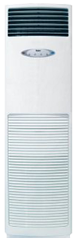

**Product Features**

* active PFC technology
* more luxury to your living room
* anti dust
* 24 hours timer
* Independent Dehumidification

**Specification**

**Type** Floor Standing AC

**Cooling (Btu/h)** 44000

**Voltage (V)** 220-240

**Power Input (W)** 5100

**EER (Btu/W-h-W/W)** 8.2-4.10